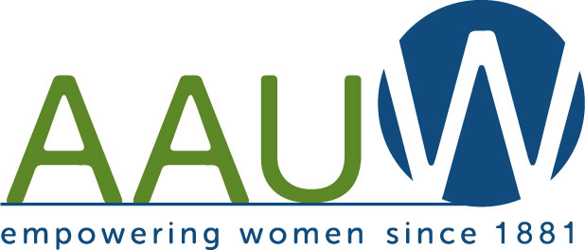
The Easton Edition
Easton, PA Branch Newsletter
October 2017 Vol. 53 No. 2

THE NEXT TWO MEETINGS - JOINT MEETINGS
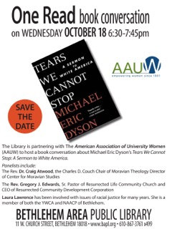

ONE READ -BOOK CONVERSATION Continured

Copies of the book are available at the libraries, Barnes and Noble, and the Moravian Book Store. This promises to be a great discussion. Parking is available under the Bethlehem Library. Let us know if you would like to car pool.

FAKE NEWS: THE MEDIA IN A POST-TRUTH WORLD
A SECOND JOINT MEETING

Saturday, November 4, 10 am - Noon
Wesley Methodist Church, 2540 Center Street, Bethlehem
Open to the Public

Moderator
Deborah Musselman
Former Director of Government Affairs for PA NewMedia Association

Panelists:
Paula Knudsen
State Government Reporter for The Caucus (a newspaper covering state legislators)

Bill White
Columnist, The Morning Call; Journalism Professor, Lehigh University

Since both of these meetings are not only joint, but also open to the public, they are considered SHAPE THE FUTURE MEETINGS.

SHAPE THE FUTURE is a recruitment tool to encourage new members to join. With this campaign, new members can take 50 percent off the national dues rate when they join on the spot during an AAUW public event. Branches also earn one free national membership to give away for every two newly recruited members, with a maximum of five free memberships. So this is a good time to invite friends to come with you to the meeting.

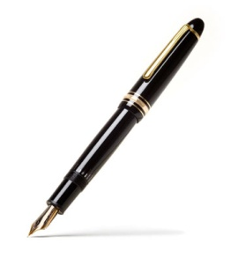
From the Presidents' Pens:
NCC named one of the best colleges for adult learners
Northampton Community College has received national recognition as one of the 100 best community colleges for adult learners nationwide by Washington Monthly. Since 2005, Washington Monthly has released an annual college guide and ranking. Schools are rated based on what they are doing for the country. For the second year in a row it has ranked the best colleges for adult learners, the first-ever ranking of its kind.
Rankings are based on data from two federal government sources as well as the College Board’s Annual Survey of Colleges and combined into seven general measures of colleges’ openness to adult students and to how well those students fared once they left. NCC ranked 60th on the nationwide list and scored high marks in ease of transfer, flexibility of programs, services for adult students, and tuition and fees.
Morning Call September 21, 2017

AAUW Easton Branch is proud of the scholarships we have been able to establish at Northampton Community College. The Jane Wait STEM Scholarship was established in May 2012 and the first scholarship was awarded in 2012-13. It is now named the AAUW Easton Branch STEM Scholarship. The Endowment was funded in 2013 and the first scholarship was awarded in 2014-15.
We would like to thank all the members of the AAUW Easton Branch whose hard work have made these scholarships and endowment possible.
Fran & Nancy
SAVE THE DATES

WEDNESDAY, OCTOBER 18, 6:30 - 7:45 PM ONE READ, BETHLEHEM LIBRARY
SATURDAY, NOVEMBER 4, 10:00 - NOON, FAKE NEWS PANEL, WESLEY METHODIST CHURCH, 2540 CENTER STREE, BETHLEHEM
FRIDAY, FEBRUARY 9, 2018, 8:00 PM EVENING AT THE WILLIAMS CENTER (SEE LAST PAGE)
SATURDAY, APRIL 21, 11:00 - 2:30 AUTHORS' LUNCHEON, POMFRET CLUB
TUESDAY, MAY 15, 7:00 PM SCHOLARSHIPS AND AWARDS DESSERT

Holiday Party and other programs - TBD

Member News - Congratulations

Rebekah "Becky" Goldenberg and her husband Hans Lauten were honored by the Easton Boys and Girls Club with the 2017 Martin Zippel Award. The Zippel award recognizes an outstanding individual, agency or business in the community that demonstrates exceptional integrity, leadership, and consistency in support of the Boys and Girls Club of Easton. Becky received the Community Service Award. Hans received the Contractor Service Award.

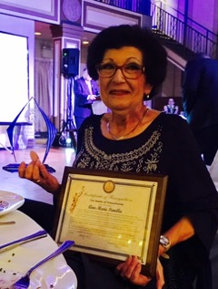
Ann-Marie Panella was honored by the Easton Area Democratic Committee with the State Senator Jeanette Reibman Award. This award recognized her many contributions to the Easton Democrats, to Palmer Township and to the community at large.

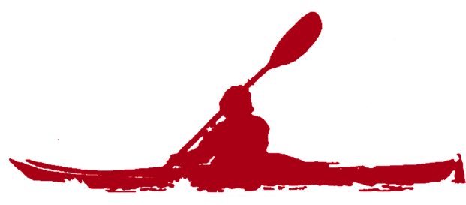
Condolences
Martha Barnett died this summer doing what she loves best in one of her favorite places, kayaking in Maine with her daughter. Martha remained active in the AAUW and life, reflecting a past filled with many accomplishments at a time when women were in a minority in the sport she became an expert in, swimming. She graduated from the University of Maine in 1946 with a major in Zoology. She became the mother of five children, 13 grandchildren and two greatgrandchildren. While raising her children she obtained an advanced degree as a swimming coach. In 1977 she became Lehigh University's head coach of the women's swim team
. Martha was proudly present with her family for her son’s performance of his new play about George Gershwin at the Ice House in Bethlehem which premiered over two weekends last Spring. She had just reached a milestone of 50 years as an AAUW member of the Easton branch having joined in 1967. We express our condolences to her family and admiration as one of our longtime members.
A memorial service for Martha O'Brien Barnett will be held on Saturday, Oct. 7, 2017, at 11 a.m., at Trinity Episcopal Church, 234 Spring Garden St., Easton, PA. Visitation with family will be held at the church from 10 to 10:50 a.m. After the service, there will be a luncheon for attendees at the church's parish hall, Conine Hall.

Peg Poswistilo died peacefully at home on Sunday, Aug. 20, 2017. Peg taught English and Latin for the Philadelphia Public Schools early on. She went on to earn a master's degree and a law degree. After her five children were of school age, she began her general practice of law (civil and criminal). She servved as the first woman Assistant Public Defender of Northampton County for 10 years. She became the first woman attorney in the Northampton Bar Association to be honored for 50 years of service. For many years she served as the attorney for the Easton Branch of AAUW. One of her favorite activities was entertaining. She was an active member of the Rotating Gourmet Group. Our deepest condolences to her husband Frank and her many family members.

Condolences also go to Aaliyah Kee on the passing of her husband Vincent after a long hospital stay. Our thoughts are with Aaliyah at this difficult time.
Northampton Community College Scholarship Recipients
The Easton Branch of the AAUW is proud to award scholarships this year to two worthy second year students Ayesha Perry and LaNae France. Both are Easton residents.
Ayesha Perry (the recipient from our endowment) is a graduate of Penn Foster high school, an online high school. This is her second year at Northampton Community College. She spent her first year at Luzerne College, Nanticoke, Pa.. Ayesha is an Early Childhood / Special Education major and was the recipient of both Phi theta Kappa and dean's list honors multiple times. She spent her early school years in Queens, NYC and credits her favorite teacher from first grade, Miss McDougal with her present career choice as a person who had a great influence on her. She enjoys gardening, reaping the benefit of her vegetable garden of cucumbers, tomatoes and zucchini. She also feels her present study has helped her with parenting her little girl who is in preschool at the Community College. Ayesha also enjoys TV cooking shows and reading Nicholas Sparks novels. She also works part time as a Home Health Care Aid. We congratulate Ayesha on her achievements which earned her this scholarship and wish her a good school year at NCC.
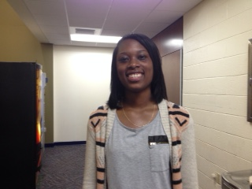
LaNae France is the recipient of our STEM scholarship. She graduated from Franklin High School, Somerset, NJ and is majoring in Biological Science. She was a four year honor student in high school and in the Gifted and Talented program in grade school. Her father’s work for Sanofi Pharmaceutical has influenced her career choice. She has volunteered in programs focused on feeding the homeless and currently is working at Country Meadows as a Med - Tech while taking a full course load. She would like her next study to be at the University of Florida majoring in Pre Med. In her spare time LaNae enjoys comedy and eating pasta, her favorite food

Notices

Regarding the Newsletter
Wouldn't you like to learn how to do a newsletter or just use WORD and put the articles together? It is a great learning opportunity and would help tremendously. If this is you, please let Fran Kennedy know.

If any member has information that they wish to have published in the newsletter, please e-mail the information to Fran Kennedy and Nancy Butow. This would include births, deaths, marriages, happenings at cultural institutions. We also encourage submissions of photos of events and anything that you think may be of interest to other members.

Please note, however, that submissions must be in by the 15th of the current month to be included in the following month's newsletter. Otherwise it will be in the following month's newsletter.

Insurance Notification
AAUW does not have an Automobile Insurance Policy. Please be informed that there is no implied or expressed authority for an AAUW member to use a member's car for AAUW business. The Easton Branch assumes no responsibility for any member using a car for this purpose.

Newsletter Ads
Do you have a business or service that you would like to promote? The charge for including an ad is only $5 for each issue. They should be no larger than business card size and they must come from members. Payment for ads should be made to the finance officer and she will notify the newsletter editor that the ad is ready to be placed.

Newsletter Costs
As officers of the branch, your board is concerned with the rising cost of printing and postage and what it does to our bottom line. If you have computer access, please consider receiving our newsletter via email. It saves the branch money and trees!

Public Policy September Highlights

Message from our AAUW-PA Public Policy Co-Chairs:

AAUW-PA Lobby Corps

The purpose of the AAUW-PA Lobby Corps is to advocate for legislation and policies that promote equity for women and girls. Our goal is to increase and strengthen AAUW’s voice in Pennsylvania. We know that when women's voices are heard it changes the conversation. We want AAUW-PA to be a consistent presence with our state legislators. Help us identify members of your branch who may be willing to commit to visiting at least one of their Harrisburg legislators either from the House or Senate at their local office this year. Your branch members may not all be in the same districts. The first step is to find out who the legislators are who represent members of your branch. If a member is not sure who their legislators are, they can go to the state web site and enter their address. It will bring up their State Representative or their State Senator. Ideally we would like to find an AAUW member to become the Lobby Corps liaison for each state House and Senate district represented in your branch. Find more information on the AAUW-PA Lobby Corps at http://aauw-pa.aauw.net/lobby-corp/

If you are interested in forming a personal relationship with your state representatives, please contact Toni for more information.

AAUW Response to Charlottesville

AAUW stands against bigotry and hate. The actions committed by white supremacists in Charlottesville over the weekend do not represent the values we hold as Americans. Our leaders must address and condemn hatred in all its forms.
It is time to unite with others who speak out against hate and show that prejudice is not patriotic, and it will not be tolerated in this country.
Posted on Facebook with a link to August 17 post on the ADL website. Lessons to teach and learn from unite the right

Pay Equity
Pennsylvania is one of five states chosen by AAUW to launch its updated research report The Simple Truth about the Gender Pay Gap. The new data will be released on September 20! Look for it here! Your AAUW-PA Public Policy Co-Chairs are working with the two prime co-sponsors of HB1243, Representatives Brian Sims and Tina Davis to hold a press conference in Harrisburg the week of September 25. Please mark Sept. 25 and 26 as possible dates for the press conference.
September 25 also marks Native American Women’s Equal Pay Day. This is the day that the wages of American Indian and Alaska Native women (58 cents for every dollar) catch up to the money white men earned last year. This date also recognizes the pay gap that Native Hawaiian and other Pacific Islander women face which is 60 cents.

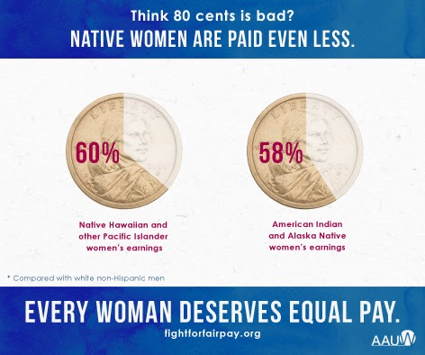
Here’s why you might not already know about this particular pay gap: Native women are a notoriously understudied group. According to AAUW’s researchers, the relatively small size of the population of Native women is at least partially responsible for the lack of information. American Indians and Alaska Natives make up just 2 percent of the U.S. population, about 5.3 million men and women. There are just 1.3 million Native people of Hawaii, Guam, Samoa, or other Pacific Islands. In contrast, there are 241 million people in the white population and 44 million in the black population. Government survey date contain less information about smaller groups.
The lack of data means that, for now, we can’t definitively say what is causing this gap, but we can hedge a few guesses. Native people face disproportionate rates of unemployment, poverty, and violence as well as limited access to education, and women tend to bear the brunt of discrimination. And yes, there's a pay gap between Native men (who in turn have a pay gap compared with other men) and Native women.
There is some good news. Native American women are now going to college and holding jobs at higher rates than ever before, and we know that education and good jobs help increase earnings — though they don't eliminate the wage gap.
This was originally written by Elizabeth Bolton and was updated by Senior Researcher Kevin Miller, Ph.D.

Redistricting Reform aka Gerrymandering

Reclaiming Our Democracy: The Pennsylvania Conference to End Gerrymandering
On Saturday, October 14, Fair Districts PA will convene a one-day redistricting conference in Harrisburg for volunteers, supporters, academics, press and legislators.
Gubernatorial candidates, legislative leaders and national redistricting experts have been invited to speak about gerrymandering and the potential for reform. Expect round-table lunches with others from your region, then afternoon breakout sessions on redistricting issues of interest.
Among other highlights: representatives from the Committee of Seventy will share plans for a citizen mapping project called Draw the Lines. This is the program AAUW-PA is focusing on for the spring. This is an opportunity to learn more about it. Thomas Wolf of the Brennan Center for Justice will give context on redistricting lawsuits and several presenters from the Tufts Geometry of Redistricting workshops will also offer a presentation.

When and Where:
Saturday, October 14, 9 AM to 5 PM (registration and coffee begins at 8 AM)
Crowne Plaza Harrisburg
23 S 2nd St., Harrisburg, PA 17101
Registration Fee: $40 / $20 for students, retirees, and unemployed . Lunch and coffee breakouts are included
Register for Conference
Accommodations:
If you require hotel accommodations, the conference has a reduced rate available with the Crowne Plaza Harrisburg, until Wednesday, September 13. To make reservations, please call the hotel at 1-800-227-6963 and reference the "FDC" room block.
The room price is $119 (plus 5% Occupancy Tax and 6% State Tax). Valet parking at the hotel is available at $20 a day charge.
Self-parking is available directly across the street at the Market Street Garage. The hotel is three blocks from the train station, so it is a short walk if you’d prefer to come by train.
For more information, contact Jim Allen - advocacy@fairdistrictspa.com

Report From Joint Brunch on Sept 9
Presentation of Survey Results Discussion Report on Merger Issues?

On September 9, 2017, more than 70 women ( 20 from the Easton branch) met for brunch to hear the results of the Inter-Branch Survey and have the opportunity to express their feelings. The first of our Saturday morning meetings was a success, starting and ending on time, thanks to the leadership of the Exploring Merger Committee ( from Easton - Rosemary Baker. Fran Kennedy and Nancy Butow attended several meetings) .

Following our meal and a raffle of AAUW-imprinted items, Linda Robertson, standing in for an ailing Stacey Zaremba, explained the survey results. Response to the survey across the three branches averaged from 42% to 54%, rather low as a solid survey response is between 75%-80%. We had 39 or of our 90 members who responded. Those who did respond to Survey Monkey seemed to represent the members who are most active. Survey questions covered how members received information about AAUW, how they felt about the possibility of merging the Allentown, Bethlehem and Easton branches, and whether they would continue their membership if any type of merger was authorized. Robertson explained that the morning discussion was only the first step in a thoughtful process.

Table discussion leaders used directed questions to stimulate conversation.
1) If the branches merged, what consequential benefits for you personally do you foresee?
2) What consequential negative impact might you personally foresee?
3) If branches merged, would you consider taking a leadership position? Many questions focused on finances, study groups, leadership, and transportation.

Results were reported out to the entire audience and will be discussed at the board level. Merging the branches is one possibility; no firm decisions have been made and our members will be kept in the information loop at all times. Any member wishing to make further comments may contact the branch co-presidents.

AAUW Annual Evening at the Williams Center
Friday, February 9, 2018
7 pm: Preconcert Talk/Business Meeting
8 pm: “Beyond Sacred: Voices of Muslim Identity” by Ping Chong & Company
After Performance: Refreshments & Discussions

Cost: $29 per ticket (ordered before Dec. 31, 2017)
$30 per ticket (ordered after Jan. 1, 2018)
A portion of each AAUW ticket goes toward local scholarships
Spouses/Friends are welcome to attend

Ping Chong is a contemporary theater director, writer, and multi-disciplinary artist who has been creating theater works for over 40 years. Chong began his Undesirable Elements project, which involves issues of race, culture, and identity, in 1992, and has received many awards and honors, including two Obie Awards and five National Endowment for the Arts fellowships. “Beyond Sacred: Voices of Muslim Identity” is part of the Tapestries project at Lafayette College, which received a grant from the Association of Performing Arts Professionals’ Building Bridges: Arts, Culture, and Identity, a component of the Doris Duke Foundation for Islamic Arts.
Chong was born in Toronto in 1946, raised in the Chinatown section of New York City, and has performed all over the world. Don’t miss this poignant new work, “a lesson in human understanding, drawn from real lives” (The New York Times).
Please send reservations to:
Phyllis Finger, 118 E. Wayne Av., Easton, PA 18042; 610 253-5040
Make checks payable to: AAUW – Easton
-------------------------------------------------------------------------------------------
Order Form: AAUW Annual Cultural Event
Name___________________________________________________________________
Tickets for “Beyond Sacred” by Ping Chong & Company - ________(qty)@$29 each
(ordered before Dec. 31)
__________(qty)@$30 each
(ordered Jan. 1-31, unless sold out)
Total of check enclosed:__________________(payable to AAUW –Easton Branch)
Interest Groups
The Easton Branch has several interest groups created to stimulate discussions, encourage networking and support the community. If you have ideas for additional groups, let us know. Every group looks forward to new participants. Call if you are interested in joining a group.

Book Discussion
Chair: Toni Hoffman- Third Monday of month
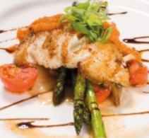
Date: October 16, 1:30pm
Hostess: Annette Stoody
Book: The Glass Universe by Dava Sobel

Diversity: Deeds and Dialogue
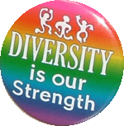
Chair: Rosemary Baker
Hostess: Rosemary Baker
Oct 25, 7:00 pm
Next 3 chapters of Racism without Rascists

Tuesday Evening Bridge Group
Chair: Rosemary Baker - Tuesdays afternoons
Call Rosemary for more information

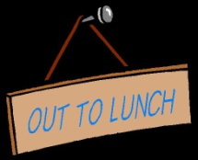
Mah Jongg
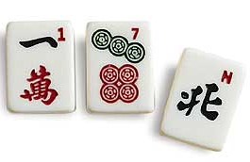
Chair : Toni Hoffman
Oct 9 10:30
Oct 23 10:30

Rotating Gourmet
Chair: Lois Wildrick
Winter and spring dinners are planned. Anyone who would like to join should contact Lois.

International Relations:
Chair: Jean Riker
Hostess: TBD
Tuesday, Oct 24, 1:30 pm
Topic:Economics in France

Out to Lunch
Chair: Claire Degnan
Wednesday, Oct 25, 12:30 pm
Marblehead Chowder House
Call Claire to reserve

American Association of University Women
AAUW National 800.326.2289 www.aauw.org
Easton Branch easton-pa.aauw.net
Co-Presidents Nancy Butow, Fran Kennedy easton-pa.aauw.net/contact/
Membership Aaliyah Kee easton-pa.aauw.net/membership/
Easton Edition

AAUW advances equity for women and girls through advocacy, education, philanthropy, and research.

In principle and in practice, AAUW values and seeks a diverse membership. There shall be no barriers to members to full participation in this organization on the basis of gender, race, creed, age, sexual orientation, national orientation, disability, or class.

The AAUW funds include the Educational Opportunities Funds (formerly a part of the AAUW Educational Foundation) which help us to advance equity for women and girls through programs such as American and International fellowships and Community Action grants.

AAUW Funds also include the Legal Advocacy Fund which provides funding and a support system for women seeking judicial redress for sexual discrimination, the Leadership Programs Fund (formerly the AAUW Leadership and Training Institute), the Eleanor Roosevelt Fund, and the Public Policy Fund.

